Smart IoT Flood Monitoring System

Phase:3 Development part 1

1. Introduction In Malaysia, floods are caused by a combination of natural and human factors. Malaysians are historically a riverine people as early settlement grew on the banks of the major rivers in the peninsula. Coupled with natural factors such as heavy monsoon rainfall, intense convection rain storms, poor drainage and other local factors, floods have become a common feature in the lives of a significant number of Malaysians [1]. Flood is tremendously dangerous and has tendency to blow the whole city and area of houses away. Flood also can cause huge property damage and loss of life. It is a natural disaster where dry land suddenly submerged under water.
2. Arduino family have their own pros and cons features. For the Arduino family, they are all almost slow with small memories and limited functionality meanwhile the Mbed platform uses ARM Cortex microcontroller which are generally have more memory spaces, much faster and more functionality. Therefore, any projects that require more memory or processing speed are recommended to use ARM platform.

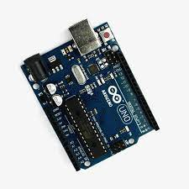

1. Methodology Methodology discusses about the approaches used to collect the data input and decision making to the public. Some improvement is needed to develop a Smart IoT Flood Monitoring System. This will focus on the system that uses the electronic based components for this project. The planning flow of this project will be explained in details. 3.1 Block Diagram From the block diagram in Figure 2, Ultrasonic HC-SR04 module sensor will be used to detect the water level of river. The mbed NXP LPC1768 is a microcontroller that will collect all the data in this system. Buzzer will act as an alarm to alert the public and authority when there is upcoming flood and data will be updated to web server. The function of LCD and LED are to display and indicate the level of water.

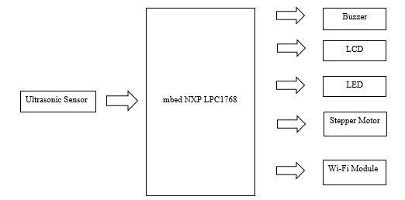

1. Flow Chart

Based on flowchart in Figure 4, Smart IoT Flood Monitoring System is developed to alert the public closest to the area when there is upcoming flood. The process is starting when ultrasonic sensor measures level of water in the river. The collected data from the sensor are gathered and will be forwarded to microcontroller and data will be displayed at web server. Then, data will be analysed and compared. As a user, he/she can control the stepper motor and buzzer wirelessly. Flood status dangerous will be determined based on that collected data. Thus, water level status will display on LCD and web server. LED will be turn on to indicate the water level. Furthermore, the stepper motor will be turn on for the passage of excessive flood when it reached at the highest threshold value and the alarm will be triggered immediately to alert the public. Hence, the citizens will be well prepared for evacuation before the flood occurred.



**5.Hardware Design Implementation**

The circuit diagram and each component connect each other. The ultrasonic sensor, stepper motor, Wi-Fi module, LED, LCD, buzzer is connected to ARM microcontroller. Ultrasonic sensor and stepper motor need at minimum 5V. to generate data meanwhile Wi-Fi module requires 3.3v only. The stepper motor interface with ARM microcontroller through driver module that connected to PWM pin. Other than that, the ESP8266 Wi-Fi module interface with SPI RX and TX pin interface.



**Result :**

Firstly, new Wi-Fi SSID and PASSWORD must be setup. Then, need to check if the Wi-Fi setup is working successfully. If the setup is success, it will get a valid IP address from a Wi-Fi router SSID and PASSWORD that have been set up. After WiFi setup gets a correct IP address = 172.20.10.13, we make that IP address in the terminal application communicate to ESP8266 WiFi module. The browser does not have Domain Name System (DNS) because we need to pay for a registered domain. To control ARM wirelessly, it must be connected to the server which the server has it own IP address. So, when it connects to the server through that IP address, the server detect that user want to connect, it will reply with the web server.

The mbed NXP LPC1768 will collect data from ultrasonic sensor every second. It measured 3 different water level distance ranged from 0 to 13 cm which is from normal, moderate and high. All the collected data will be display on Smart IoT Flood Monitoring Web Server and LCD.



**Conclusion**

Nowadays the Internet Of things (IoT) is broadly used in worldwide, this system will display the data of the water level measured on web server. If there is continuous heavy rain, user can simply monitor the water level through laptop or mobile phone wherever they are as long there is an internet connection. At the same time, this smart system can also control the alert signal and the gate to let the excessive water flows wirelessly. The system can be more enhanced by sending SMS as warning signal to citizens for those did not subscribe mobile data or did not have any internet connection.